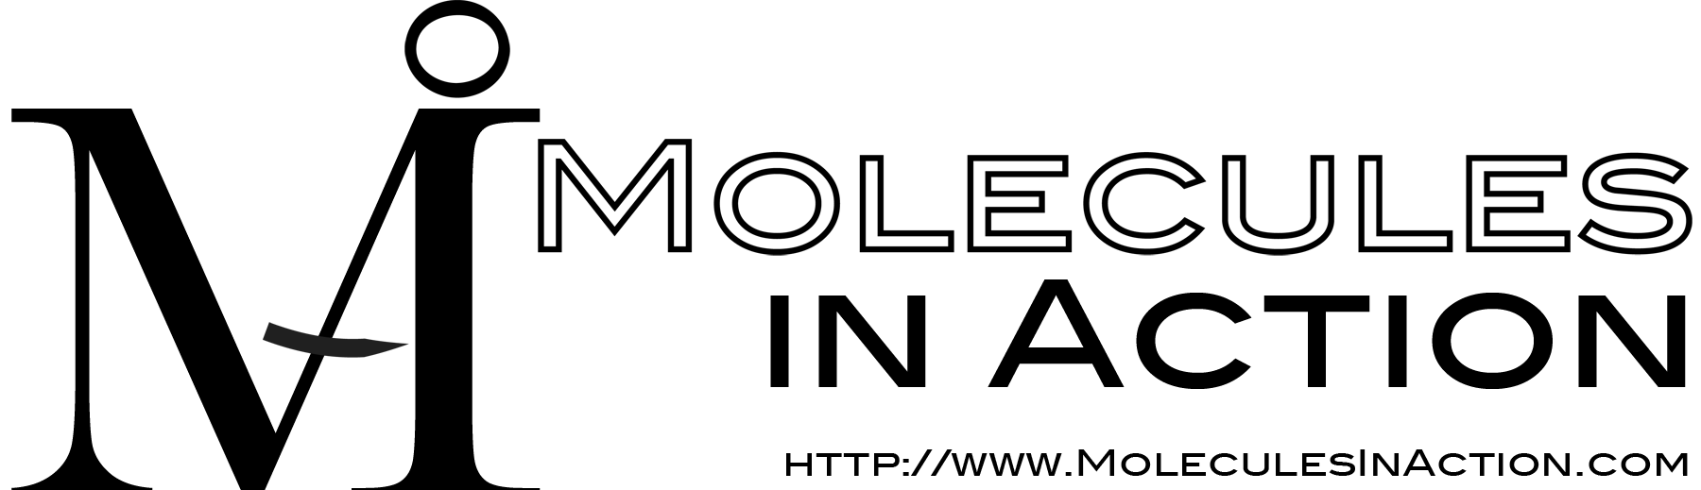

1. This licensed copy of the Eris stand-alone Software may only be used by you and members of your organization. The Software remains at your organization and is not published, distributed, or otherwise transferred or made available to other than Institution employees and students involved in research under your supervision. You may make only those copies of the Software which are necessary to install and use it as permitted by this Agreement, or are for purposes of backup and archival records; all copies shall bear the SOFTWARE copyright and proprietary notices.

2. You retain in Software and any modifications to Software as provided by Molecules in Action, LLC. You may modify the software, and use it to create derivative works, for your internal use at the organization covered by this license. You may not distribute such modified or derivative software to others outside of your site without written permission from by Molecules in Action, LLC. You may distribute the modifications themselves (e.g. as “patches”) under terms of your choice.

3. You provide the Developers with feedback (feedback-eris@moleculesinaction.com) on the use of the Software in your research, and that the Developers and Molecules in Action, LLC are permitted to use any information you provide in making changes to the Software. All bug reports and technical questions shall be sent to the support list provided by the Developer.

4. You acknowledge that the Developers and Molecules in Action, LLC, and its licensees may develop modifications to Software that may be substantially similar to your modifications of Software, and that the Developers and Molecules in Action, LLC, and its licensees shall not be constrained in any way by You in Molecules in Action, LLC’s or its licensees’ use or management of such modifications. You acknowledge the right of the Developers and Molecules in Action, LLC to prepare and publish modifications to Software that may be substantially similar or functionally equivalent to your modifications and improvements, and if You obtain patent protection for any modification or improvement to Software You agree not to allege or enjoin infringement of your patent by the Developers and Molecules in Action, LLC or by any of Molecules in Action, LLC licensees obtaining modifications or improvements to Software from the Molecules in Action, LLC or the Developers.

5. Your will acknowledge in your publications contributions involving or based on the Software. The current citations for Software are
(1) S. Yin, F. Ding, and N. V. Dokholyan, “Modeling backbone flexibility improves protein stability estimation” Structure, 15: 1567-1576 (2007),

and

(2) S. Yin, F. Ding, and N. V. Dokholyan, “Eris: An automated estimator of protein stability” Nature Methods, 4: 466-467 (2007).

6. Any risk associated with using the Software at your institution is with You and your Institution. Software is experimental in nature and is made available as a research courtesy “AS IS,” without obligation by Molecules in Action, LLC to provide accompanying services or support.

7. MOLECULES IN ACTION, LLC AND THE DEVELOPERS EXPRESSLY DISCLAIM ANY AND ALL WARRANTIES REGARDING THE SOFTWARE, WHETHER EXPRESS OR IMPLIED, INCLUDING BUT NOT LIMITED TO WARRANTIES PERTAINING TO NON-INFRINGEMENT, MERCHANTABILITY OR FITNESS FOR A PARTICULAR PURPOSE.

________________________ __________________________________________
Last, First Name Organization

________________________ __________________________________________
Signature Date

